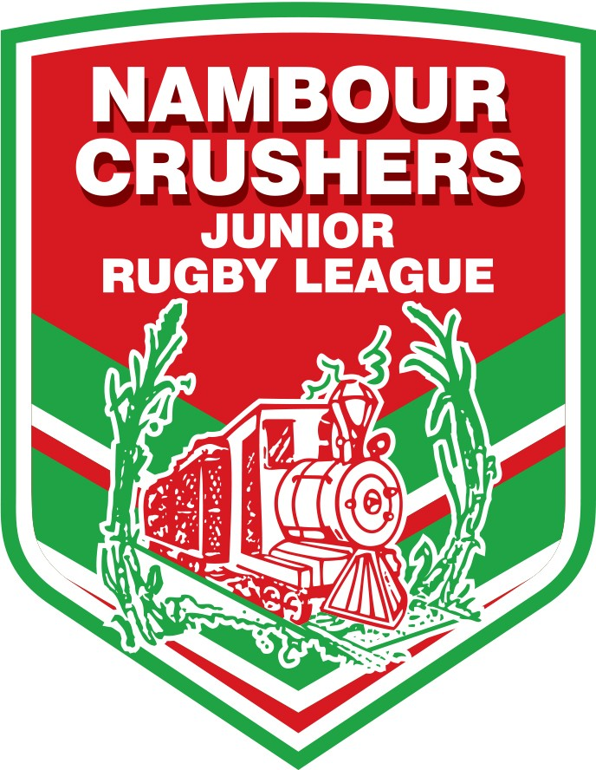

NAMBOUR JUNIOR RUGBY LEAGUE CLUB COACHING APPLICATION - SEASON 2022
Applications Close: FRIDAY 29th OCTOBER 2021
Name: Address:
Email Address: Telephone No.: Date of Birth |  | Mobile:  Occupation
YOU MUST PROVIDE THE FOLLOWING COACHING/TRAINING CERTIFICATE DETAILS (Where Applicable).
IF YOU DO NOT HAVE ANY OF THE BELOW QUALIFICATIONS YOU MUST BE PREPARED TO UNDERTAKE THE APPROPRIATE COURSE
ALL COACHING STAFF MUST HOLD A CURRENT BLUE CARD PRIOR TO COMMENCEMENT OF POSITION
COACHING CERTIFICATE Mini Folio No.
Mod Folio No.
International Folio No.
Level 1 Folio No.
Senior Club Coach -­‐ Level 2 Folio No.
Blue Card No.: Expiry Date:

Team Applying For: 1st Preference
2nd Preference
Outline Coaching Experience:
Reason for Applying for this Team:
If I am selected as a Coach I will abide by the Code of Conduct as set out by the NRL, SCJRL and Nambour Junior Rugby League.

Signed: Date:
I acknowledge that if I am successful in gaining a Coaching Position for the season, I will be responsible, with my Coaching Staff for fulfilling the following:

- Attending all Coaches meetings and sessions as organised by the Club
- Arranging for my team to participate in all Club organised fundraisers
- Arranging for my team to assist in Canteen, set up and pack up duty when directed by the Club

Signed: Date:

Please return your Application marked: 2022 Coaching Application via email to secretary@juniorcrushers.com.au.

